Graphical Processing Systems

2021-2022

Project Documentation

Chereji Iulia-Adela

Group 30434-1

14.01.2022

Contents

1 Subject specification - 3 -

2 Scenario - 3 -

2.1 Scene and objects description - 3 -

2.2 Functionalities - 6 -

3 Implementation details - 7 -

3.1 Functions and special algorithms - 7 -

3.1.1 Possible solutions - 7 -

3.1.2 The motivation of the chosen approach - 7 -

3.2 Graphics model - 7 -

3.3 Data structures - 7 -

3.4 Class hierarchy - 7 -

4 Graphical user interface presentation / user manual - 7 -

5 Conclusions and further developments - 7 -

6 References - 7 -

# Subject specification

For this project I decided to do a small farm scene using OpenGl. The time passes in the scene so we can see it during the day and during the night. With the background and the grass on the ground I wanted to make it look like a summer day. I took the farmhouse object from one of this semester’s laboratory resources and I kept building the scene around it so that’s how it became a farm.

# Scenario

The scene looks like a courtyard next to a stable. There are a two bulls that stay next to a few trees in the shadow. There is a lamp in the left side with a light sensor that turns on in the evening and off in the morning, and a windmill that powers the lamp. The farmer can walk around the closed yard and he has a flashlight for when he checks on the animals at night time. The scene is surrounded by a long stall and a fence. Sometimes there is fog in the area but not very thick.

## Scene and objects description

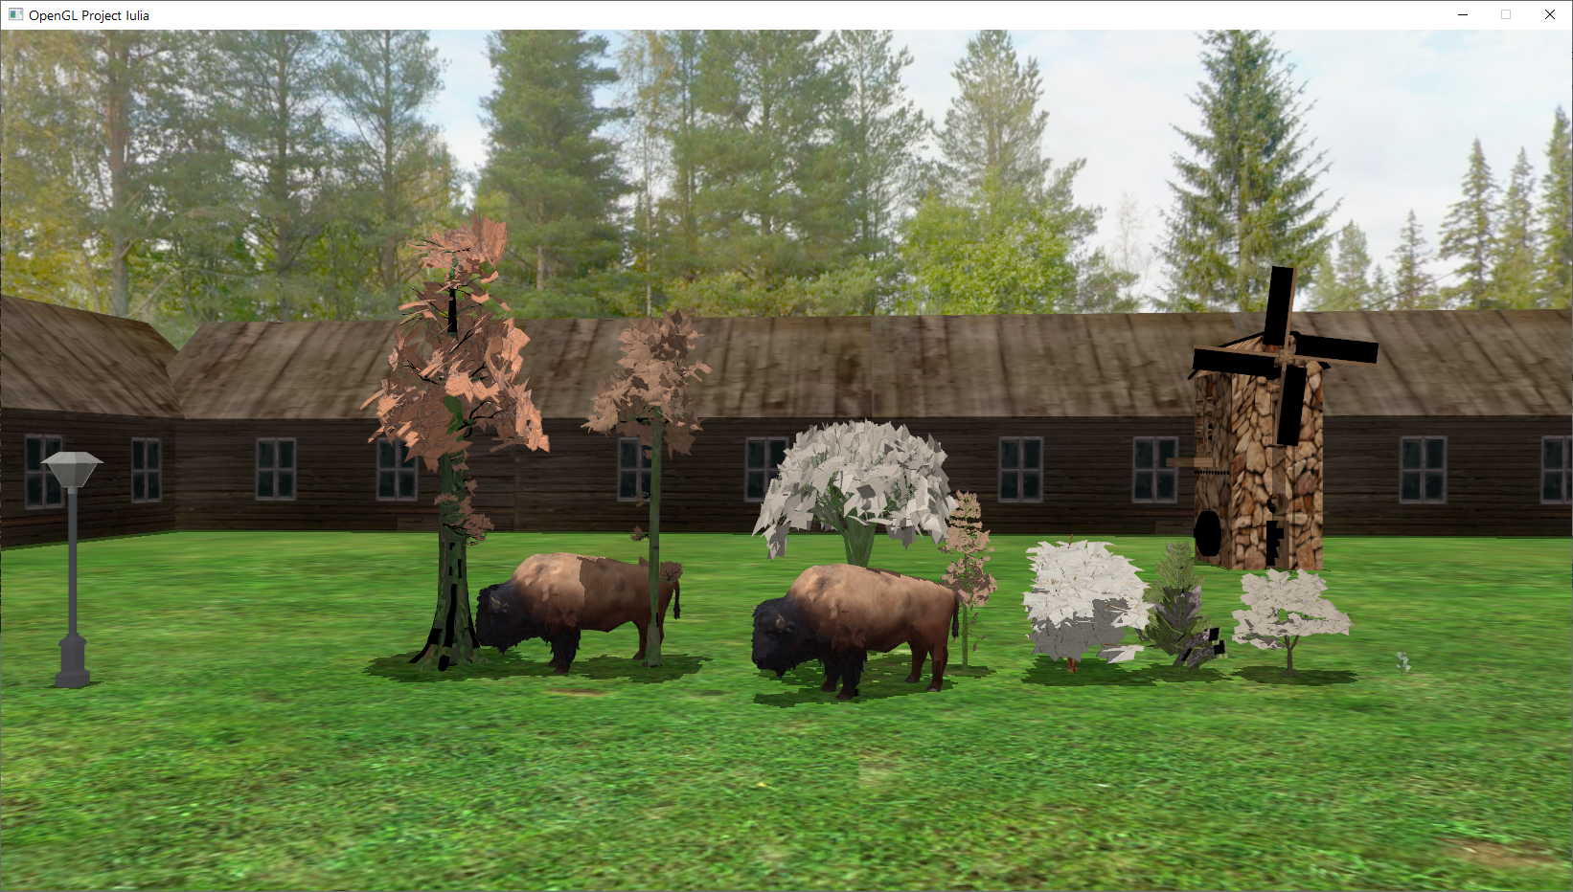

The scene represents a summer day at the farm. The background is a Skybox object with the image of some trees and a blue house. The ground is a square 3D object on which I mapped a grass texture and there are in total 4 squares in the scene.

All the objects that can be found in the scene are .obj files with .mtl texture files associated. The .mtl files map the objects coordinates to the ones of some pictures (.jpg or .png) The objects are:

* The grass is made out of 4 ground objects that I took from one of the laboratories’ resources but I replaced the texture image with a green grass image.
* The sky is a Skybox object on which I mapped 6 images of a skybox I found on the internet.

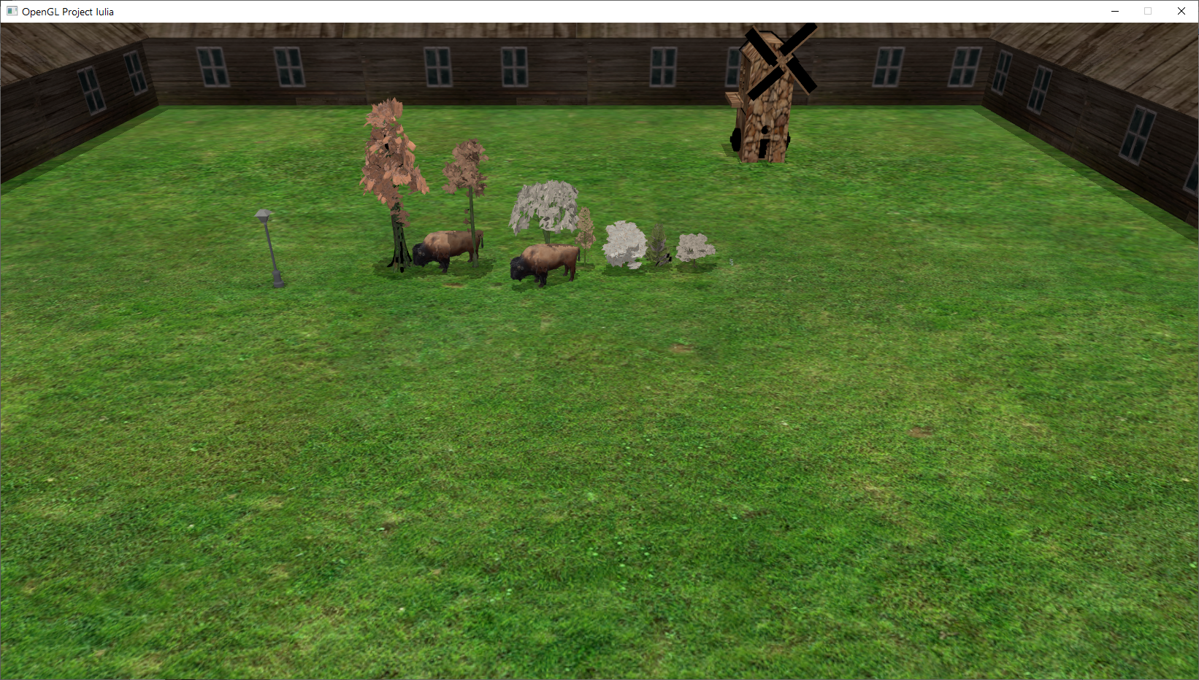

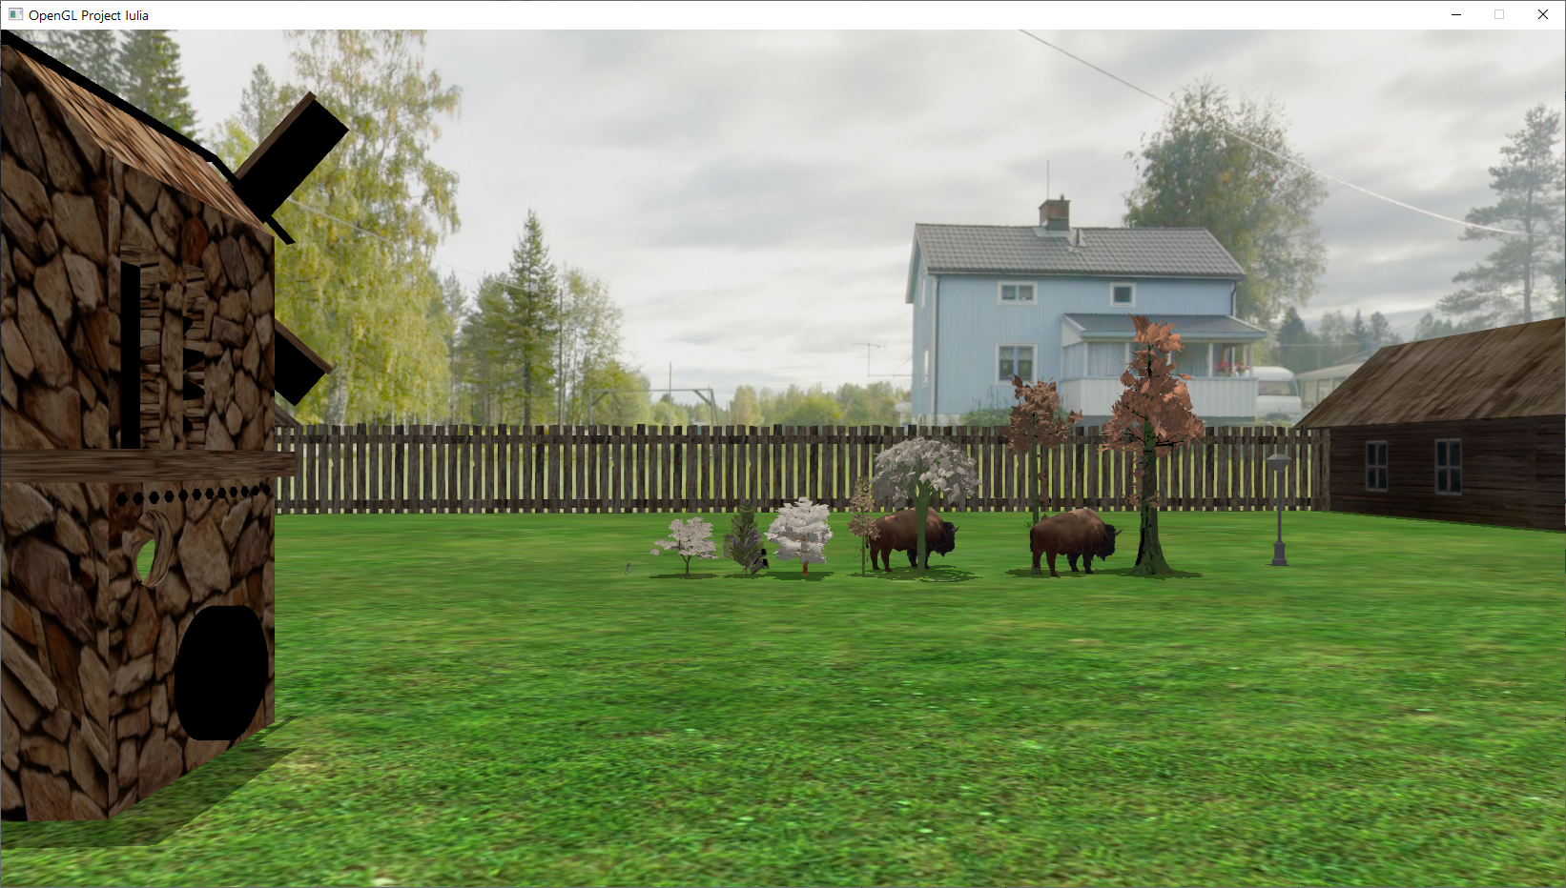

* 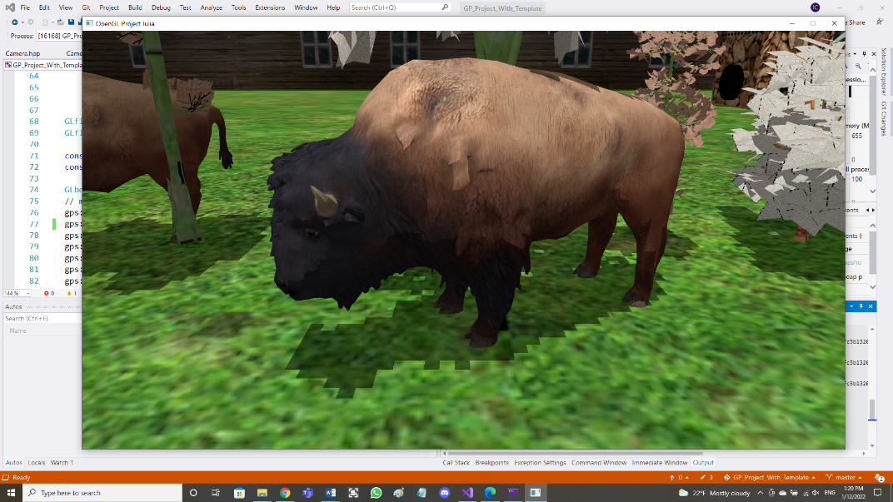The 2 bulls are the same object, drawn twice. I downloaded all of their components (.obj, .mtl, .png). They have smooth surfaces.
* The street lamp is also downloaded from the internet. And

I made it seem like a source of light.

* The trees are downloaded from the internet and they are the

most complex object in the scene. They have a lot of details

and if I add more the application runs very slow.

* The windmill’s body and it’s airscrew are downloaded as 2

different objects. They used to have another color but I put the

image of a rock wall on it. The reason for which I chose to

have 2 different objects is that I wanted to make the airscrew rotate.

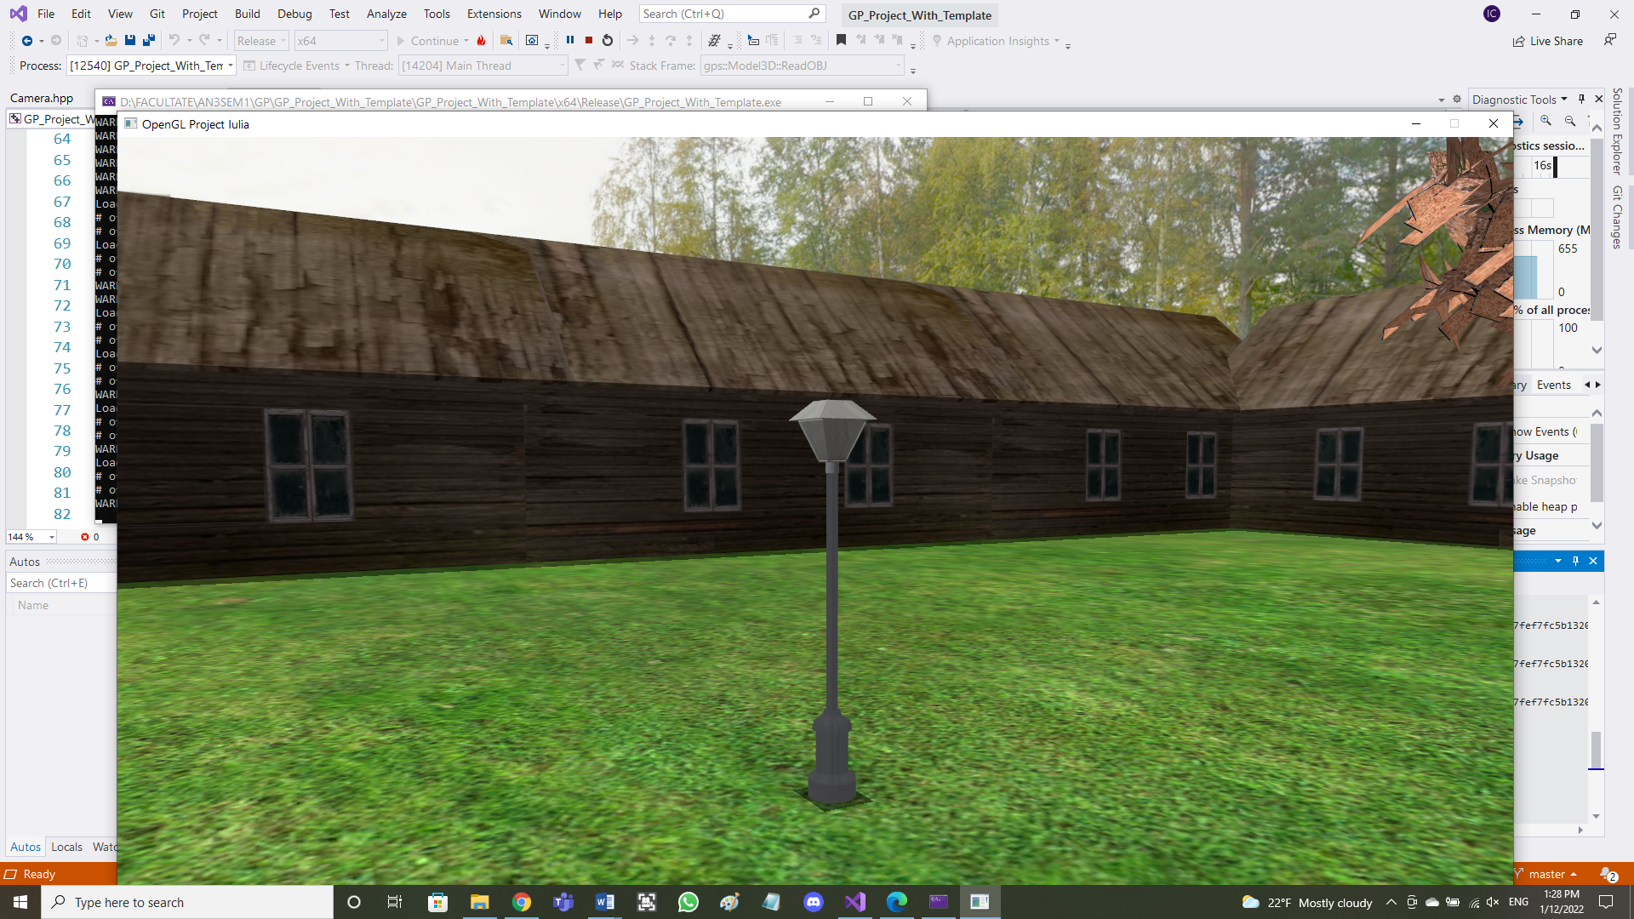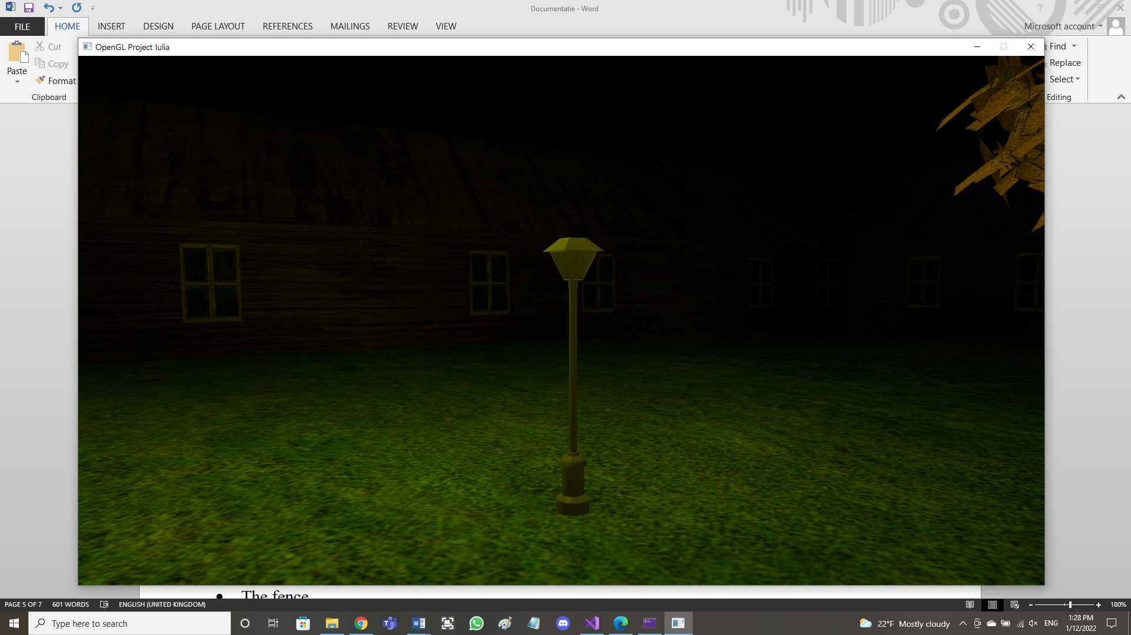

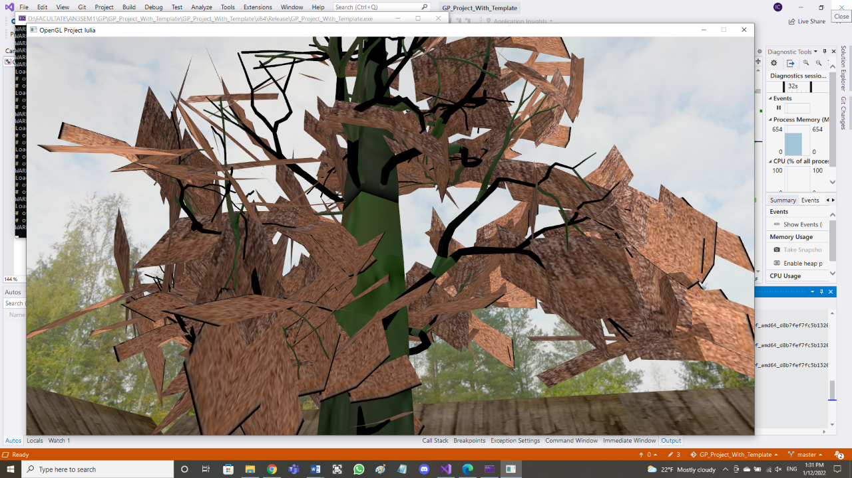

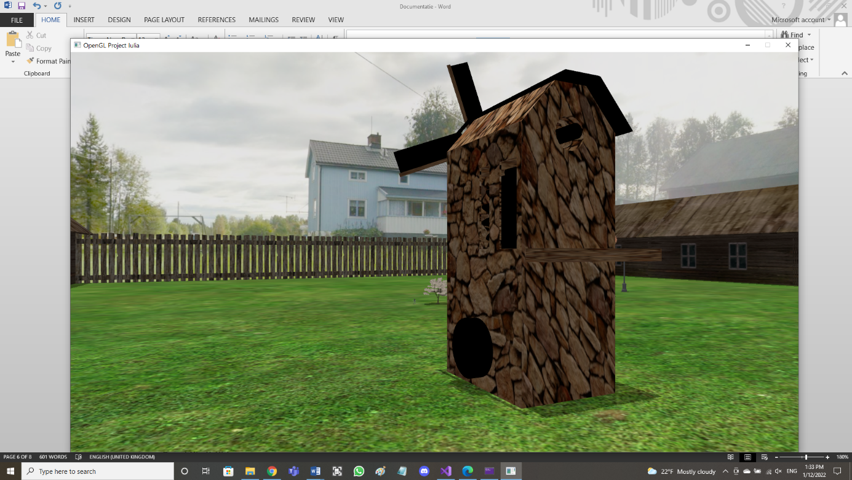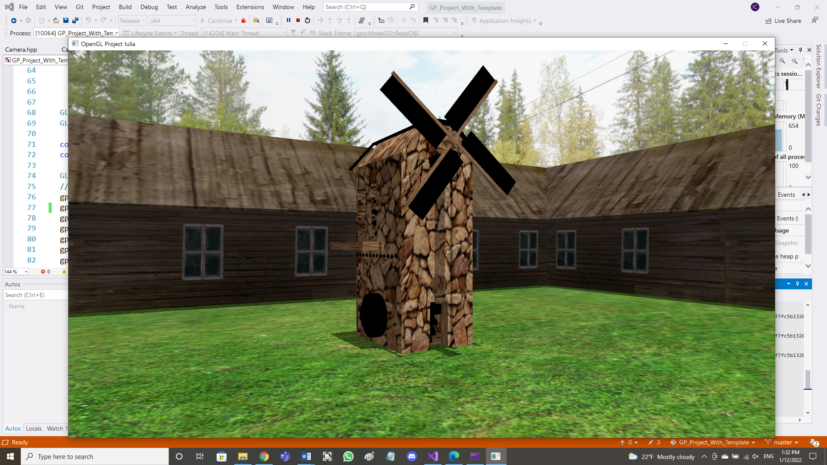

* The stall is composed of more farmhouse objects that I took from the laboratory resources and put them next to each other to give the impression of a long surrounding stall.
* The fence is downloaded from the internet but it originally had no .mtl texture so the program could only draw it black. But I created a .mtl file and I downloaded a wood image to map onto it. Then I put more fence objects next to each other to create a longer fence.
* The light cube which appears only when the ‘C’ key is pressed to show the position of the directional light.

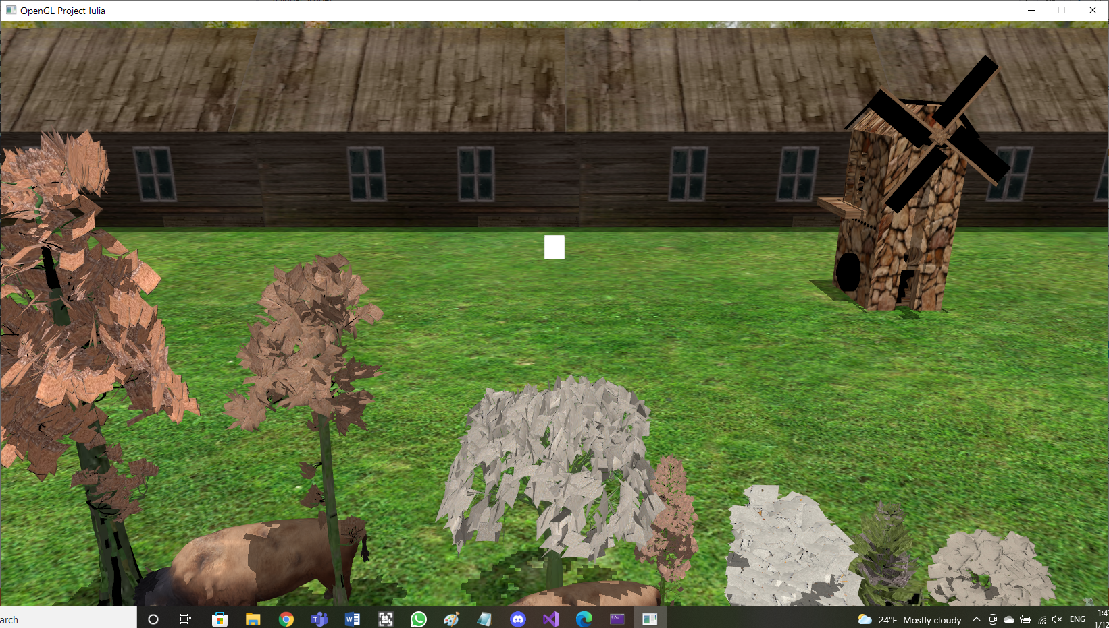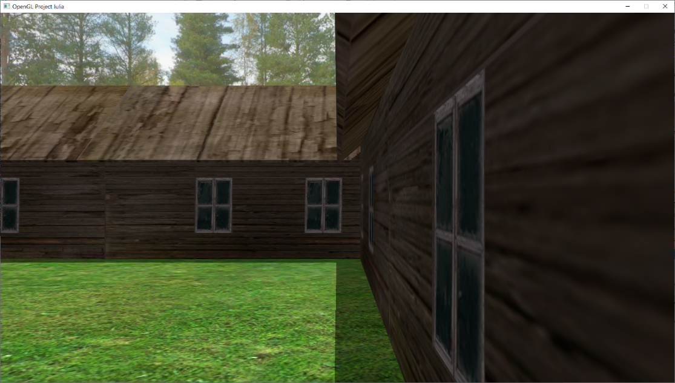

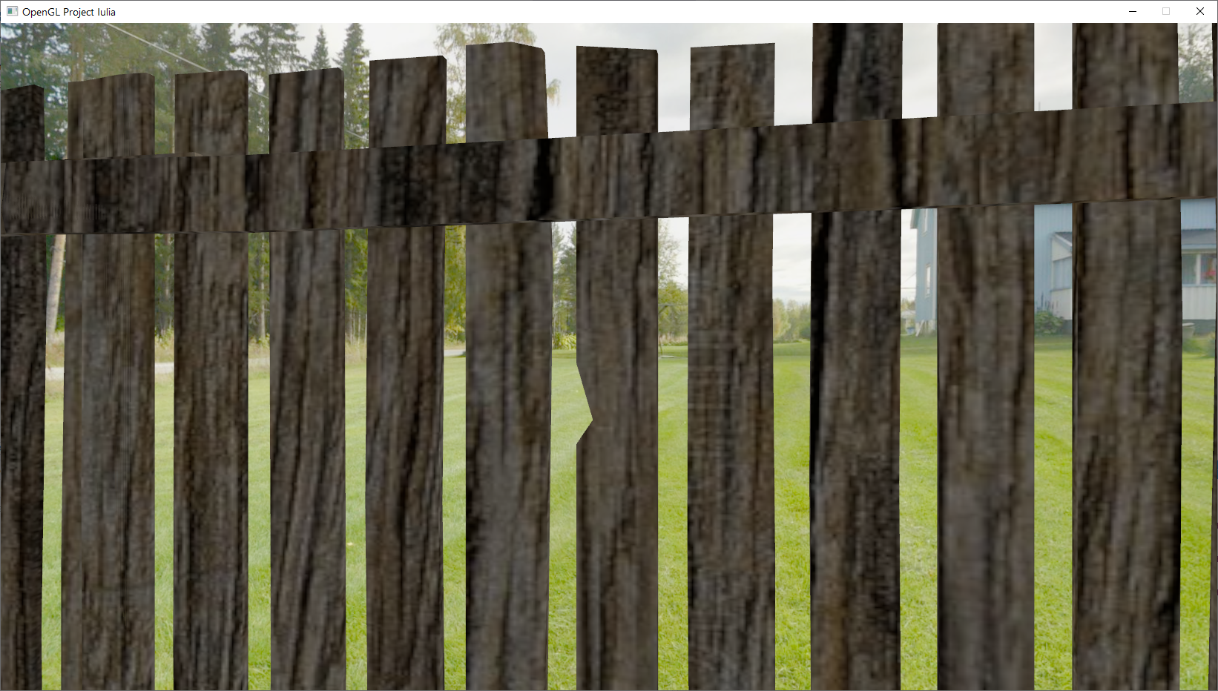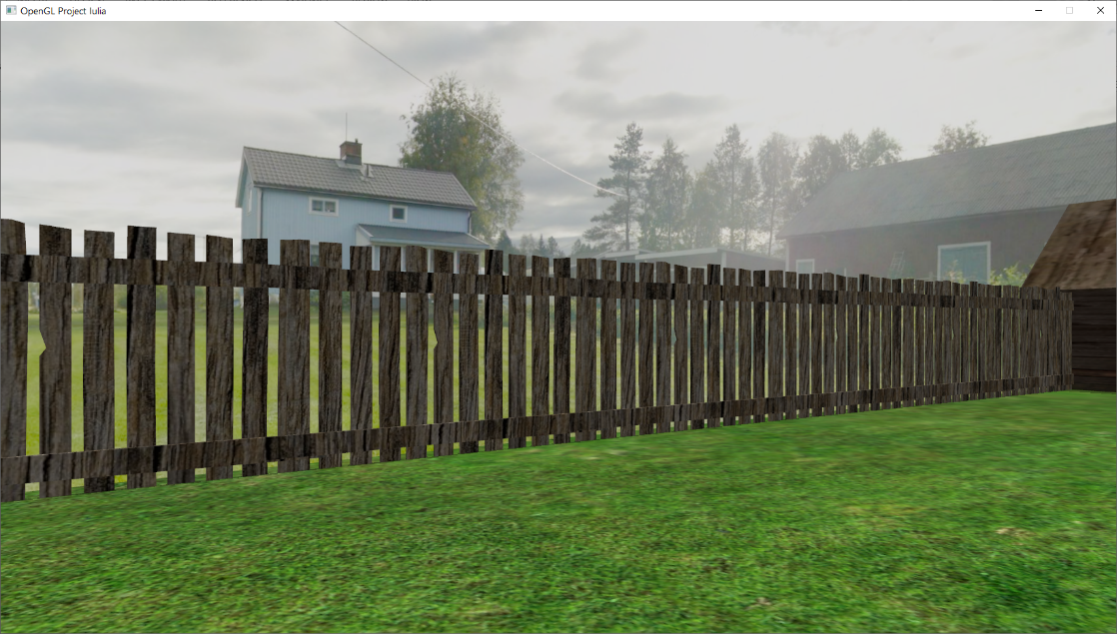

## Functionalities

* Visualization of the scene:
* Camera movement
* Specification of light sources:
* Viewing solid, wireframe objects, polygonal and smooth surfaces
* Texture mapping and materials
* Shadows:
* Animation of object components

# Implementation details

## Functions and special algorithms

### Possible solutions

### The motivation of the chosen approach

## Graphics model

## Data structures

## Class hierarchy

# Graphical user interface presentation / user manual

# Conclusions and further developments

# References